Stats

Table of contents

── Attaching packages ─────────────────────────────────────── tidyverse 1.3.2 ──  
✔ ggplot2 3.3.6 ✔ dplyr 1.0.10  
✔ tibble 3.1.8 ✔ stringr 1.4.1   
✔ readr 2.1.3 ✔ forcats 0.5.2   
✔ purrr 0.3.4   
── Conflicts ────────────────────────────────────────── tidyverse_conflicts() ──  
✖ dplyr::filter() masks stats::filter()  
✖ dplyr::lag() masks stats::lag()  
Registered S3 method overwritten by 'GGally':  
 method from   
 +.gg ggplot2  
  
Rows: 111 Columns: 4  
── Column specification ────────────────────────────────────────────────────────  
Delimiter: ","  
dbl (4): radiation, temperature, wind, ozone  
  
ℹ Use `spec()` to retrieve the full column specification for this data.  
ℹ Specify the column types or set `show_col_types = FALSE` to quiet this message.

## 1 Question 1 a)

|  |
| --- |
| Exercise 1 a) |

## 2 Question 1 b)

|  |
| --- |
| Exercise 1 b) |

## 3 Question 1 c)

Part 1 of exercise 1 c)

|  |
| --- |
| Exercise 1 c) part 1 |

Part 2 of exercise 1 c)

|  |
| --- |
| Exercise 1 c) part 2 |

## 4 Question 2 a)

Part 1 of exercise 2 a)

|  |
| --- |
| Exercise 2 a) part 1 |

Part 2 of exercise 2 a)

|  |
| --- |
| Exercise 2 a) part 2 |

## 5 Question 2 C)

# set.seed(26041999)  
  
candidateBWins = 0  
  
## Here we set the number of times we will estimate  
  
## largeNumberOfExtimations = 1000000 reducing the number so it doesn't  
## take an hour to compile  
largeNumberOfExtimations = 1e+05  
  
for (i in 1:largeNumberOfExtimations) {  
  
 candidateB = 175 ## candidate B initial votes/support  
 candidateM = 184 ## candidate M initial votes/support  
  
 ## increment for each day from the initial day to the final day,  
 ## the 14th  
 for (i in 1:14) {  
  
 ## will be used to hold the new value of votes that continue to  
 ## support the same candidate  
 candidateBAuxCalc = 0  
 candidateMAuxCalc = 0  
  
 ## here we will estimate how many candidates still support the  
 ## same candidate by generating a vector where 1 means they  
 ## still support the same candidate after the end of each day  
 ## the 0 represent them changing the support and vote from one  
 ## candidate to another  
 candidateBAuxCalc = sum(sample(c(1, 0), candidateB, replace = TRUE,  
 prob = c(0.996, 0.004)))  
 candidateMAuxCalc = sum(sample(c(1, 0), candidateM, replace = TRUE,  
 prob = c(0.995, 0.005)))  
  
 ## here we calculate the number of votes that will be exchanged  
 ## by the candidates, so the votes that are subtracted from  
 ## what they had previously  
 votesMovedFromCandidaBToCandidateM = candidateB - candidateBAuxCalc  
 votesMovedFromCandidaMToCandidateB = candidateM - candidateMAuxCalc  
  
 ## here calculate that the new current votes for each candidate  
 ## by adding the current votes from the mps that still support  
 ## the same candidate plus the number of votes of the mps that  
 ## exchanged support for their candidate  
 candidateB = candidateBAuxCalc + votesMovedFromCandidaMToCandidateB  
 candidateM = candidateMAuxCalc + votesMovedFromCandidaBToCandidateM  
  
 }  
 ## check if the candidate B did win the election by holding the  
 ## majority of the votes  
 if (candidateB > candidateM) {  
 candidateBWins = candidateBWins + 1  
 }  
  
}  
  
## probability estimation of candidate B winning after 14 days of  
## campaign by holding the majority of the votes  
  
probabilityB = candidateBWins/largeNumberOfExtimations  
  
probabilityB

[1] 0.3574

As we can see the probability of candidate B winning after 14 days is approximately 0.35

## 6 Question 2 d)

# set.seed(26041999)  
  
candidateBWins = 0  
  
## Here we set the number of times we will estimate  
## largeNumberOfExtimations = 1000000 reducing the number so it doesn't  
## take an hour to compile  
largeNumberOfExtimations = 1e+05  
  
for (i in 1:largeNumberOfExtimations) {  
  
 candidateB = 175 ## candidate B initial votes/support  
 candidateM = 184 ## candidate M initial votes/support  
  
 ## increment for each day from the initial day to the final day,  
 ## the 60th  
 for (i in 1:60) {  
  
 ## will be used to hold the new value of votes that continue to  
 ## support the same candidate  
 candidateBAuxCalc = 0  
 candidateMAuxCalc = 0  
  
 ## here we will estimate how many candidates still support the  
 ## same candidate by generating a vector where 1 means they  
 ## still support the same candidate after the end of each day  
 ## the 0 represent them changing the support and vote from one  
 ## candidate to another  
 candidateBAuxCalc = sum(sample(c(1, 0), candidateB, replace = TRUE,  
 prob = c(0.996, 0.004)))  
 candidateMAuxCalc = sum(sample(c(1, 0), candidateM, replace = TRUE,  
 prob = c(0.995, 0.005)))  
  
 ## here we calculate the number of votes that will be exchanged  
 ## by the candidates, so the votes that are subtracted from  
 ## what they had previously  
 votesMovedFromCandidaBToCandidateM = candidateB - candidateBAuxCalc  
 votesMovedFromCandidaMToCandidateB = candidateM - candidateMAuxCalc  
  
 ## here calculate that the new current votes for each candidate  
 ## by adding the current votes from the mps that still support  
 ## the same candidate plus the number of votes of the mps that  
 ## exchanged support for their candidate  
 candidateB = candidateBAuxCalc + votesMovedFromCandidaMToCandidateB  
 candidateM = candidateMAuxCalc + votesMovedFromCandidaBToCandidateM  
  
 }  
 ## check if the candidate B did win the election by holding the  
 ## majority of the votes  
 if (candidateB > candidateM) {  
 candidateBWins = candidateBWins + 1  
  
 }  
  
}  
  
## probability estimation of candidate B winning after 14 days of  
## campaign by holding the majority of the votes  
  
probabilityB = candidateBWins/largeNumberOfExtimations  
  
probabilityB

[1] 0.77276

As we can see the probability of candidate B winning after 60 days is approximately 0.77

## 7 Question 3 a)

|  |
| --- |
| Exercise 3 a) |

## 8 Question 3 b)

|  |
| --- |
| Exercise 3 b) |

## 9 Question 3 c)

|  |
| --- |
| Exercise 3 c) |

## 10 Question 3 d)

|  |
| --- |
| Exercise 3 d) |

## 11 Question 4 c)

vectorY = c(0.573, 0.77, 0.652, 0.827, 0.821, 0.789, 0.898, 0.718, 0.382,  
 0.668, 0.647, 0.477, 0.661, 0.38, 0.87, 0.794, 0.783, 0.732, 0.629, 0.777,  
 0.6, 0.724, 0.553, 0.693, 0.687, 0.935, 0.494, 0.411, 0.53, 0.478)  
  
# rt <- polyroot(t)

## 12 Question 5 a)

summary(ozone)

radiation temperature wind ozone   
 Min. : 7.0 Min. :57.00 Min. : 2.300 Min. : 1.0   
 1st Qu.:113.5 1st Qu.:71.00 1st Qu.: 7.400 1st Qu.: 18.0   
 Median :207.0 Median :79.00 Median : 9.700 Median : 31.0   
 Mean :184.8 Mean :77.79 Mean : 9.939 Mean : 42.1   
 3rd Qu.:255.5 3rd Qu.:84.50 3rd Qu.:11.500 3rd Qu.: 62.0   
 Max. :334.0 Max. :97.00 Max. :20.700 Max. :168.0

Here we can see that wind and ozone have some pretty extremely high max values compared to both the median

ggpairs(ozone, lower = list(continuous = "smooth"), diag = list(continuous = "barDiag"),  
 axisLabels = "show")

`stat_bin()` using `bins = 30`. Pick better value with `binwidth`.  
`stat_bin()` using `bins = 30`. Pick better value with `binwidth`.  
`stat_bin()` using `bins = 30`. Pick better value with `binwidth`.  
`stat_bin()` using `bins = 30`. Pick better value with `binwidth`.

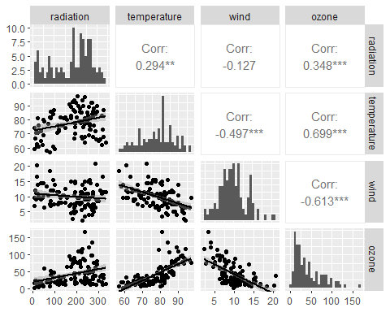

Firstly, as it can be observed in the graph that ozone has a very significant positive skewness and is possibly normally distributed. It also noticeable from the ozone histogram that it resembles a normal distribution with positive skewness.

We can also observe that temperature have a positive and strong linear correlation with ozone with only a small amount of variance overall with the exception of a few points between the 3rd quartile and the maximum, we can also see that there is a a positive slope meaning that as temperature increases the amount of ozone detected increases as well.

Furthermore, radiation has a positive correlation with ozone so radiation has a positive effect on ozone. The variance is more extreme between the 2nd quartile and maximum but maintaining a relatively low variance between the minimum and the 2nd quartile.

Lastly, Wind’s has a negative correlation with ozone, meaning that has wind increases the less ozone is detected. Most of the variance below the line of best fit, is between the first and third quartile while the values that are more on the extreme, between the the minimum and 1st quartile and the 3rd quartile and the maximum are almost all above the line of best fit. The wind histogram also displays what looks to be a normal distribution with close to zero skewness with some irregularities near the 15 bin.

##question 5 b)

model = lm(ozone ~ radiation + temperature + wind, data = ozone)  
  
summary(model)

Call:  
lm(formula = ozone ~ radiation + temperature + wind, data = ozone)  
  
Residuals:  
 Min 1Q Median 3Q Max   
-40.485 -14.210 -3.556 10.124 95.600   
  
Coefficients:  
 Estimate Std. Error t value Pr(>|t|)   
(Intercept) -64.23208 23.04204 -2.788 0.00628 **   
radiation 0.05980 0.02318 2.580 0.01124 *   
temperature 1.65121 0.25341 6.516 2.43e-09 ***  
wind -3.33760 0.65384 -5.105 1.45e-06 ***  
---  
Signif. codes: 0 '***' 0.001 '**' 0.01 '*' 0.05 '.' 0.1 ' ' 1  
  
Residual standard error: 21.17 on 107 degrees of freedom  
Multiple R-squared: 0.6062, Adjusted R-squared: 0.5952   
F-statistic: 54.91 on 3 and 107 DF, p-value: < 2.2e-16

## we can observe that the intercept so when \t  
  
## residuals are the values of the differences between the line we made  
## and the observations  
  
## the coefficients are the point estimations intercept is the beta0  
## and the wt is the beta1

First thing we can observe is the confidence intervals of the 3 variables, both the temperature and wind have confidence intervals of 99,9% as it can be see by the 3 stars next to their respective p-values, radiation is in the 95% confidence interval but is close to the 99% confidence interval, meaning all 3 variables have a significant association and and are a meaningful addiction to our model. Significance being p-values < 0.05.

We can also see by the value of the R-squared and adjusted R-squared that this model around 60% of the variation in ozone levels.

From the estimates we can than wind is the variable with the biggest impact per unit however when comparing it is also important to compare using the minimum and maximum values so we can determine how much each of the independent variables have been recorded to affect the ozone readings so we will be using the minimum and maximum to determine the maximum and minimum variance.

About the Coefficients, we can observe that radiation is the least impactful of the 3 independent variables, the changes in ozone radiation detected vary between [0.4186,19.9732] from the minimum and maximum values, which compared to the [94.11897,160.16737] minimum and maximum variance from the temperature readings which is by far the most impactful variable or the [-7.67648,-66.752] variance from the minimum and maximum values from the wind readings.

Are these findings consistent with your earlier descriptive plots? Also include suitable residual plots, commenting as appropriate.

## 13 the intercept value is impossible so lets grpah what we have and have a look

Coefficients: Estimate Std. Error t value Pr(>|t|)  
(Intercept) -64.23208 23.04204 -2.788 0.00628 ** radiation 0.05980 0.02318 2.580 0.01124 *  
temperature 1.65121 0.25341 6.516 2.43e-09 ***wind -3.33760 0.65384 -5.105 1.45e-06***

radiation temperature wind ozone  
Min. : 7.0 Min. :57.00 Min. : 2.300 Min. : 1.0  
1st Qu.:113.5 1st Qu.:71.00 1st Qu.: 7.400 1st Qu.: 18.0  
Median :207.0 Median :79.00 Median : 9.700 Median : 31.0  
Mean :184.8 Mean :77.79 Mean : 9.939 Mean : 42.1  
3rd Qu.:255.5 3rd Qu.:84.50 3rd Qu.:11.500 3rd Qu.: 62.0  
Max. :334.0 Max. :97.00 Max. :20.700 Max. :168.0

$β0=β1$

plot(model)

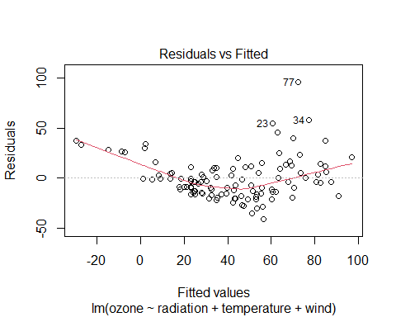

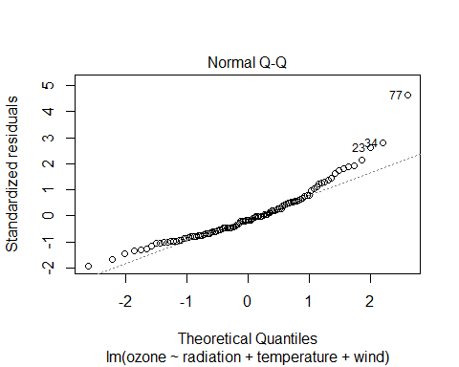

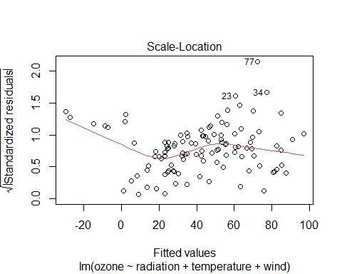

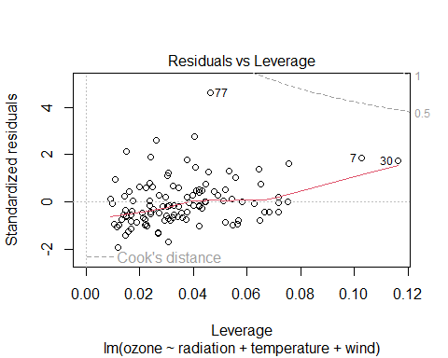

## a residual is the distance between our data points and our  
## regression line

As observed here on Residuals vs Fitted graph

##question 5 c)

## log(ozone) = β0+β1 log(radiation)+β2 log(temperature)+β3  
## log(wind)+εi where εi ∼ N (0, σ2) β0 = intercept  
  
modelLogFriend = lm(log(ozone) ~ log(radiation) + log(temperature) + log(wind),  
 data = ozone)  
  
  
summary(modelLogFriend)

Call:  
lm(formula = log(ozone) ~ log(radiation) + log(temperature) +   
 log(wind), data = ozone)  
  
Residuals:  
 Min 1Q Median 3Q Max   
-1.63961 -0.30073 -0.00097 0.34414 1.11545   
  
Coefficients:  
 Estimate Std. Error t value Pr(>|t|)   
(Intercept) -10.55570 2.08818 -5.055 1.79e-06 ***  
log(radiation) 0.30500 0.05868 5.198 9.73e-07 ***  
log(temperature) 3.20478 0.46019 6.964 2.79e-10 ***  
log(wind) -0.66305 0.13751 -4.822 4.74e-06 ***  
---  
Signif. codes: 0 '***' 0.001 '**' 0.01 '*' 0.05 '.' 0.1 ' ' 1  
  
Residual standard error: 0.4907 on 107 degrees of freedom  
Multiple R-squared: 0.6876, Adjusted R-squared: 0.6788   
F-statistic: 78.49 on 3 and 107 DF, p-value: < 2.2e-16

summary(model)

Call:  
lm(formula = ozone ~ radiation + temperature + wind, data = ozone)  
  
Residuals:  
 Min 1Q Median 3Q Max   
-40.485 -14.210 -3.556 10.124 95.600   
  
Coefficients:  
 Estimate Std. Error t value Pr(>|t|)   
(Intercept) -64.23208 23.04204 -2.788 0.00628 **   
radiation 0.05980 0.02318 2.580 0.01124 *   
temperature 1.65121 0.25341 6.516 2.43e-09 ***  
wind -3.33760 0.65384 -5.105 1.45e-06 ***  
---  
Signif. codes: 0 '***' 0.001 '**' 0.01 '*' 0.05 '.' 0.1 ' ' 1  
  
Residual standard error: 21.17 on 107 degrees of freedom  
Multiple R-squared: 0.6062, Adjusted R-squared: 0.5952   
F-statistic: 54.91 on 3 and 107 DF, p-value: < 2.2e-16